

|  |  |
| --- | --- |
| ***Module Title:*** | ***DATA VISUALIZATION*** |
| ***Module Code:*** | ***B9DA106*** |
| ***Module Leader:*** | ***Basel Magableh*** |
| ***Assessment Title:*** | ***Exploratory Data Analysis*** |
| ***Assessment Type:*** | ***Group (4)*** |
| ***Student Names:*** | ***Pavithra Krishnamurthy*** |
| ***Student ID:*** | ***10387862*** |
| ***Student Names:*** | ***Prathibha Kubera*** |
| ***Student ID:*** | ***10393895*** |
| ***Student Names:*** | ***B.L. Meghana*** |
| ***Student ID:*** | ***10386493*** |
| ***Student Names:*** | ***Suraj Suresh*** |
| ***Student ID:*** | ***10391218*** |

**ACKNOWLEDGEMENT**

Initially, we need to frame the team members to form a group of 3-4 members for the project work assigned by our professor of Dublin Business School. Keeping that in a mind that these members would be working together with us as a team for the final project work. Hence, it was mandatory for each individual to get along from the start for the smooth processing of the project.

Team Members:

Since, we had to submit our group registration form to our professor by 17 th March 2019; we had chosen our team and started working on the project from 12th March 2019. Our Team members include:

1. B.L.Meghana

2. Prathibha Kubera

3. Pavitra Krishnamurthy

4. Suraj Suresh

As we all belong to the same class of Dublin Business School, we decided to work on the Data visualization project work, made the time schedule to complete our target, shared the work equally, gathered all the requirements for the project work and built the interactive graphs.

As the timeline was 45 days hardly, we spent every day by doing step by step in our project. The work which was assigned to each team members, we used to discuss the progress of our project every week and if there were any chance to modify for the betterment, we used to do the same.

Git Hub Link : https://github.com/meghana555/Global-Terrorism

**Contents**

Introduction 4

DATASET SELECTION 5

INITIAL ANALYSIS QUESTION 5

DISCOVERY AND INSIGHTS 5

DESCRIPTION for each visualization 6

**Barplot analysis for attacks on Attack Type, Weapon Types, and Victims** 6

**MAP PLOT Analysis on single crime traget type in different countries** 9

**bubble map plot analysis on crime target type in Ireland cities** 10

**Line plot analysis about the Extent of Damage to Property over the Years** 11

**Circle Plot analysis about the Fatalities due to Terrorist attacks** 12

**Horizontal Bar Graph analysis about the Terrorist Organizations Responsible for the Attacks** 13

**Horizontal Bar Graph analysis about the Terrorist Organizations Responsible for the Attacks** 14

**Bubble Graph analysis about the Worst Terrorist Attack countries through years** 15

**Heatmap Graph analysis about the worst Terrorist Attacks through years** 16

**Stacked Bar Graph analysis about the Terrorist attack casuality through years** 16

**Bar Graph with mean line analysis about the Terrorist mode of claim** 17

CONCLUSION 17

# Introduction

Global Terrorism Database (GTD) is an open-source database including data on terrorist attacks occasions far and wide from 1970 through 2017 (with extra yearly updates arranged). In contrast to many other databases, the GTD incorporates deliberate information on local just as transnational and worldwide fear-based oppressor episodes that have happened amid this timeframe and now incorporates in excess of 180,000 cases. For each GTD episode, data is accessible on the date and area of the occurrence, the weapons utilized and nature of the objective, the quantity of setbacks, and- - when recognizable - the gathering or individual mindful.

Measurable data contained in the Global Terrorism Database depends on reports from an assortment of open media sources. Data isn't added to the GTD except if and until we have decided the sources are solid. Clients ought not induce any extra activities or results past what is displayed in a GTD section and explicitly, clients ought not deduce an individual related with an occurrence was attempted and indicted for fear-based oppression or some other criminal offense. On the off chance that new documentation around an occasion ends up accessible, a passage might be adjusted, as important and proper.

The National Consortium for the Study of Terrorism and Responses to Terrorism (START) makes the GTD accessible by means of this online interface to build comprehension of psychological oppressor brutality so it very well may be more promptly examined and crushed.

# DATASET SELECTION

The dataset which we chosen for this assessment is Global Terrorism Database (GTD). It contains the information about the terrorist attacks all around the world from 1970 – 2017 and it has more than 1,81,000 attacks during this period.

Dataset link: <https://www.kaggle.com/START-UMD/gtd>

Attributes: eventid, iyear, imonth, iday, approxdate, extended, resolution, country, region, provstate, city, latitude, longitude, specificity, vicinity, location, summary, etc. It contains more 100 variables.

# INITIAL ANALYSIS QUESTION

1. In which Year the amount of damage caused for the Property?
2. In which Attack Type/Weapon Type/ Target Type Category the Attack count is high and low?
3. In which county terrorist attack is high?
4. Which is the most widely used mode of communication for the terrorist to claim their Responsibility?
5. What is the most common motive behind the terrorist attacks?
6. Which City in Ireland is mostly got attacked by terrorist?
7. Which terrorist organization has made highest number of attacks?
8. In which Year the terrorist attack caused maximum cost of property damage?
9. Maximum number of deaths during the terrorist attack?
10. Number of people wounded and dead during the terrorist attack during the years?
11. Number of people wounded and dead during the terrorist attack in various countries?

# DISCOVERY AND INSIGHTS

1. For whom these questions/issues are important and what kind of actionable intelligence you expect to gather:
2. We need to know for whom this insight is more valuable to? It will be more help to our Military force like Air Force, Army, Coast Guard, Marine Corps, Navy to the country to know the statistics of the terrorist attacks.
3. Military Force can come the strategy to defend and prevent the country from the terrorist attack
4. It will help us in understanding the measure of terrorist attack in various aspect like what mode of communication they are using during the terrorist attack and what strategy they followed during the years
5. With the given data Military Force can initiate new training strategy for the soldiers to be prepared for the attack and prevent the attack from happening
6. Also, Military Force can prepare the scenario, if any worst things are happened like food, shelter for the citizen who were affected during the attack
7. In which Country/City the Military Force needs to be more attentive because terrorist attack is not happening everywhere, it will happen the major countries and major cities
8. From the previous record the Military will get to know which organization most of the terrorist attack and what ways did they have used.
9. Using the given information, Military can create the high threat alert on the terrorist organization and capture them or prevent them from next terrorist attack.

# DESCRIPTION for each visualization

## **Barplot analysis for attacks on Attack Type, Weapon Types, and Victims**

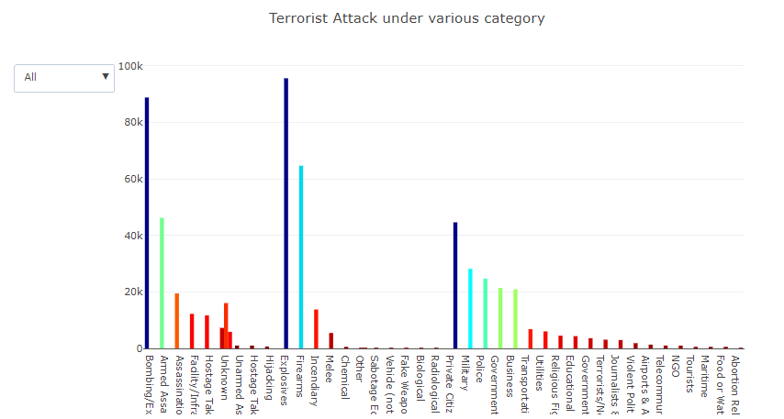

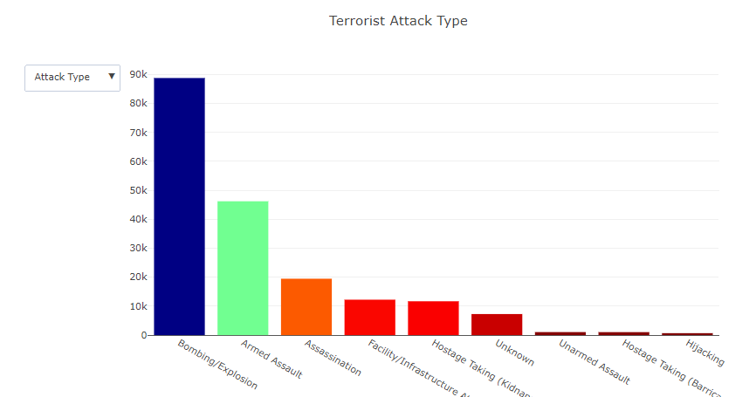

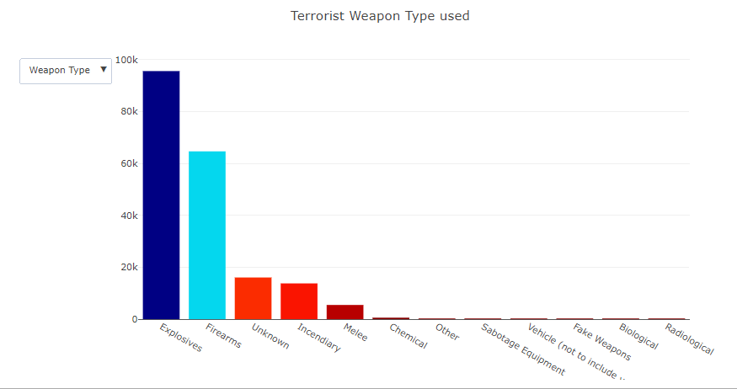

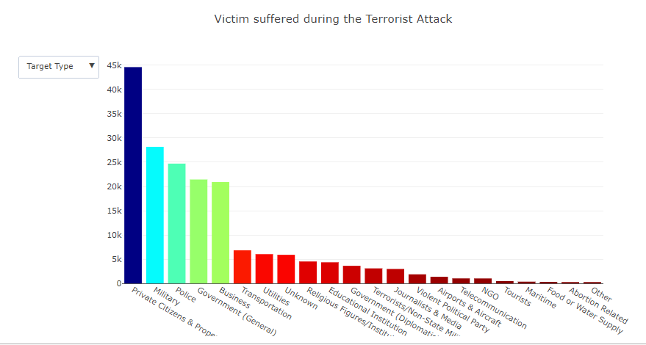

Description: - This plot gives the Overview/Summary of terrorist attack counts under different attack type, weapon type and target type who suffered the most in it. “Attack Types” represents the type of attacks made by the terrorist. In Attack type the Bombing is mostly classified other than any other types in attacks, In Weapon Type the mostly used is Explosives and in the Target Type widely used is Private Citizens & Property. The purpose is to understand and have a brief overview of types of Attacks in different dimensions. It presents the number of attacks made by the each types. And presenting the highest in it.

## **MAP PLOT Analysis on single crime traget type in different countries**

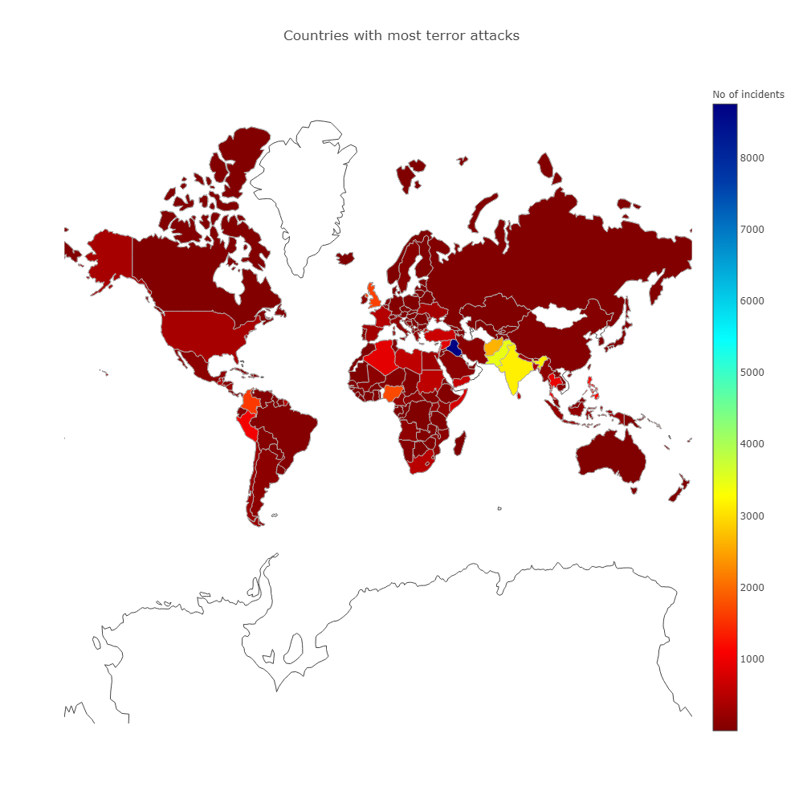

**Description: -** In the map plot, we are visualizing the terrorist attack happened in all around the world. The highest number of crimes happened in Iraq which is 8747 attacks and the second highest is India and Pakistan with above 3000 attacks. The interesting factor is we have interval range of terrorist attack from 1 to above 8500. Fiji which is recorded with 1 terrorist attack in this crime type. Is to know the country which is been affected by the terrorist attacks. It presents the number of countries got attacked by the terrorist and highest in it.

## **bubble map plot analysis on crime target type in Ireland cities**

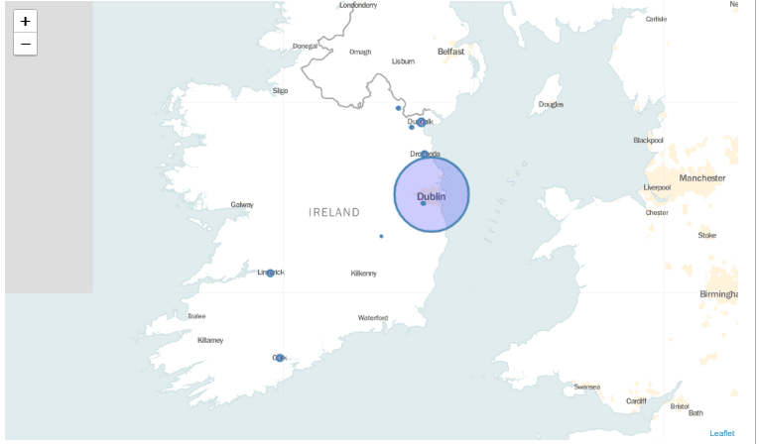

Description: In this Map Plot, we can see the highest crime happened in Dublin city among other cities in Ireland. The interesting factor is the terrorist attack count is recorded as above 120 in Dublin when it comes to other cities is not even above 20. Is to know the Cities which is been affected by the terrorist attacks in Ireland. It presents the number of Cities in Ireland got attacked by the terrorist and highest in it.

**Word Cloud analysis on the motive behind the terrorist attack – atleast should give measure**

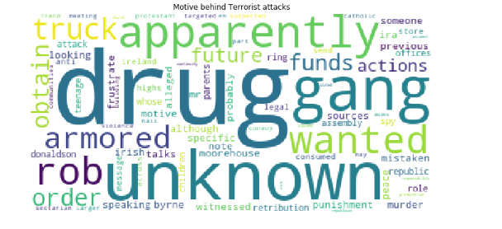

Description: Depends on the size of the text, we will get to know the motive of the highest number of crimes happened in Ireland. Most of the terrorist attacks happened become of the drugs, many were unknown. Is to know about the motive of the terrorist for the attacks. It presents wording for which can be the attacks is made and highest in it.

## **Line plot analysis about the Extent of Damage to Property over the Years**

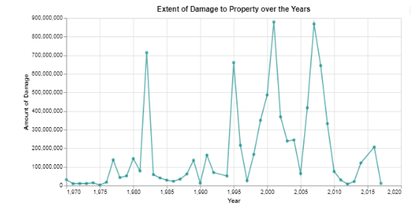

Description: The cost of the property damage happened in terrorist attack from 1970 to 2017. Around 900 Billion worth of the property were damaged during the terrorist attack in 2001 and 2007 in the Major property damage category. It got reduced after 2010 and it is very less before 1981 damage happened for the properties per year. It presents the highest damages held from 1970 – 2017 and giving highest in it.

## **Circle Plot analysis about the Fatalities due to Terrorist attacks**

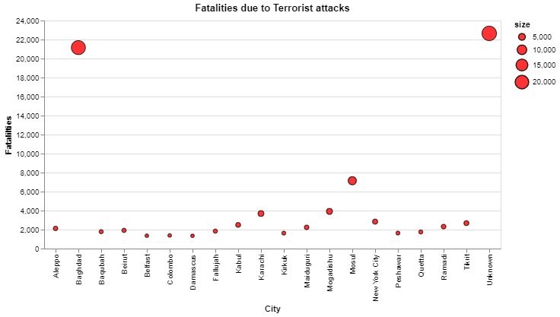

Description: In this plot, we are seeing the number of people died in the terrorist attack including the terrorist and victims. The highest number of people died in Baghdad city and count is around 21,000. Is to know about the cities which is been act for the highest number of deaths by the terrorism. It presents the cities from all over the world with the number of deaths by the terrorist attacks.

## **Horizontal Bar Graph analysis about the Terrorist Organizations Responsible for the Attacks**

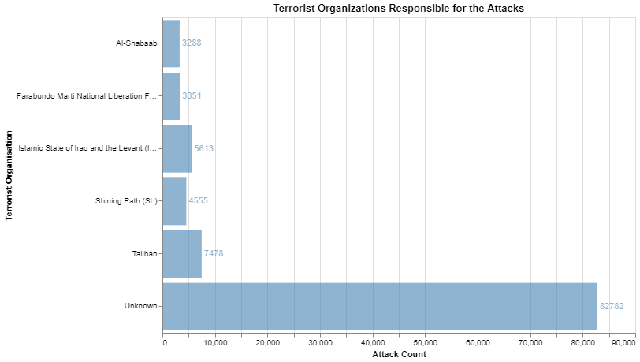

Description: The Bar Graph above pictures the psychological oppressor assaults by various fear-based oppressor associations. We have plotted the chart with the psychological militant association versus their assault checks. The power of the shading in the bar relies on the quantity of assaults, The darker the shading, the higher the assaults tallies of the gathering. Taliban bunch has toppled every other gathering. Many organizations don’t claim the responsibility of the attacks. As indicated by information Taliban (Afghanistan) is the most dynamic gathering on the planet with 7478 assaults till 2017. It is trailed by ISIL (middle east, 5613 assaults) . Sparkling path (4555 assaults) at next, and Al-Shabaab at the least. Is to know which organization made the highest number of attacks. It presents the count of attacks made by each terrorist organization.

## **Bubble Graph analysis about the Worst Terrorist Attack countries through years**

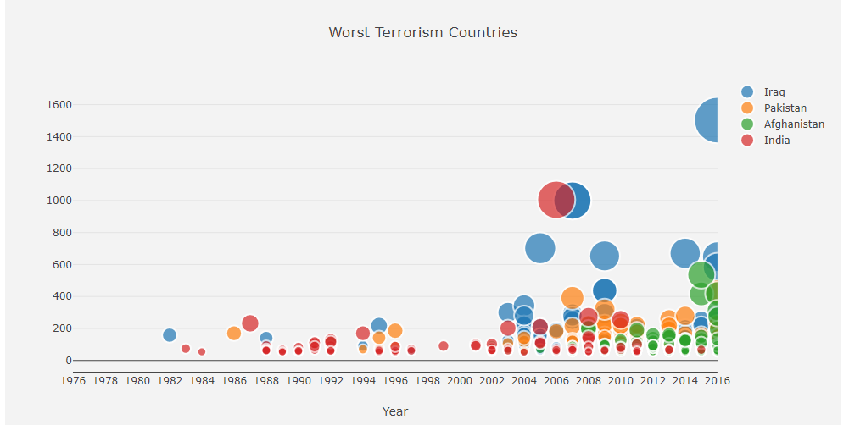

Description: Global Terrorism Index demonstrated a proceeding with pattern of a decrease in psychological oppression, with passings from fear mongering falling for the third back to back year, subsequent to cresting in 2014. The absolute number of passings fell by 27% somewhere in the range of 2016 , with the biggest falls happening in Iraq . It likewise demonstrates that psychological oppression is as yet far reaching, and notwithstanding deteriorating in certain locales.

## **Heatmap Graph analysis about the worst Terrorist Attacks through years**

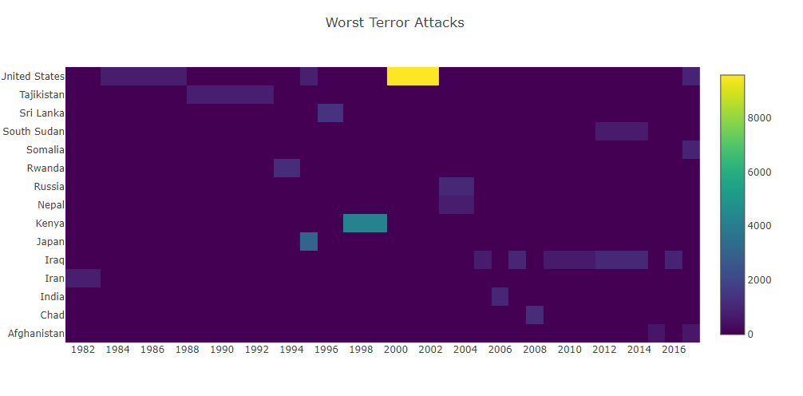

Description: Throughout the years, fear mongers have guaranteed several blameless lives. In present day times, dread keeps on reigning in our boulevards consistently. From the roads to the war-dug urban areas of Iraq, to Nairobi and Angola in Africa, and crosswise over Iran and the Persian Gulf, psychological militants are all over.

## 

## **Stacked Bar Graph analysis about the Terrorist attack casuality through years**

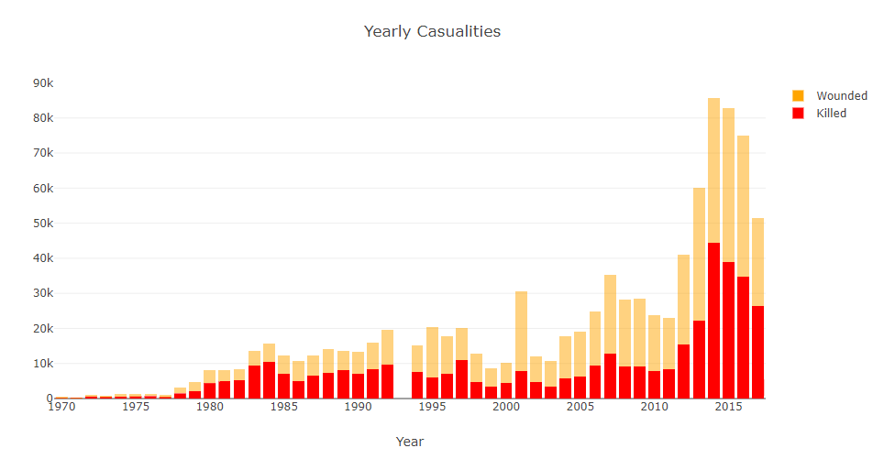

Description: In the above graph we see the quantity of fatalities from fear-based oppressor assaults amassed by district. Over this multiyear timespan we see that a few districts have specific times of moderately high casualty numbers. We see that over the previous decade, the causalities have started increasing. In 2015, it’s the most where more people have been wounded.

## **Bar Graph with mean line analysis about the Terrorist mode of claim**

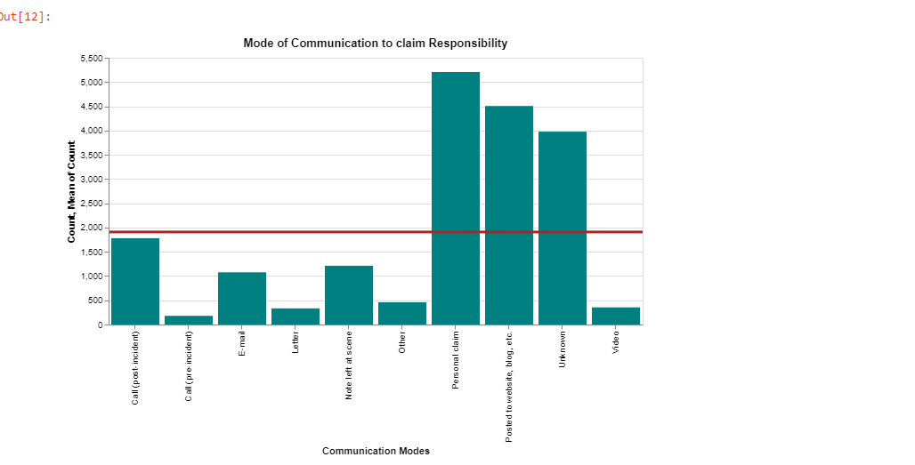

Description: Dispensable Sim cards. Modest and legitimately accessible for money, these can be purchased namelessly over the counter, embedded into a cell phone, utilized once and afterward discarded. Dead drops. An old Cold War technique utilized by covert agents to drop off physical bundles of data or photos in spots like fences or behind dustbins. Email and SMS instant message. Watchful psychological militant organizers have would in general convey in code or use illustrations while talking about targets, realizing they likely could be blocked. Online networking visit rooms and gaming. USB sticks. A little and attentive approach to convey huge amounts of information, they are additionally profoundly defenseless against malware and infections. Messenger by hand. The strategy that worked for a considerable length of time.

# CONCLUSION

It is clear to interpret the information about the analysis in the interactive Visualization. We have used various charts and graphs in an interactive way to grab audience attendance and interest to travel along the side of it. From the visualization, we are more concentrated on the City, Country, Weapon, Victim, People killed during the terrorist attack. To sum up all, we can clearly see the highest terrorist attack happened using Bombing/ Explosives, and most of the target were the attacks in public areas including markets, commercial streets, busy intersections and pedestrian malls. Iraq is the highest suffered country and Baghdad city (Capital of Iraq) which suffered the most in the terrorist attack. We can conclude Iraq is the dangerous country among all the other in the world.